HOUSING ACT 1985, Schedule 5A

Public Notice of Initial Intent to Demolish

Our Ref: HB/Stonebroom1

- We, Rykneld Homes Limited, for and on behalf of North East Derbyshire District Council (“the Council”), give public notice that the Council intends to demolish buildings 1-50 The Bungalows, Birkinstyle Road, Stonebroom DE55 6LH, for the following reasons:

- The Purpose of the demolition of the existing bungalows is necessary for the regeneration and development of energy efficient new build bungalows.

- The period within which it is intended to demolish the building or buildings described in the attached Schedule by 2nd January 2028, which is the date when any initial demolition notice or notices relating to the building or buildings described in the attached Schedule will cease to be in force unless revoked or otherwise terminated under or by virtue of Paragraph 3 of Schedule 5A to the Housing Act 1985.

- During the period of validity of any initial demolition notice or notices relating to the building or buildings described in the attached Schedule the Council will not be under any obligation to transfer any such dwelling-houses contained in those premises (by way of a grant such as is mentioned in section 138(1) of the Housing Act 1985) in pursuance of any claims made to exercise the right to buy.

- There may be a right to compensation under Section 138C of the Housing Act 1985 in respect of certain expenditure incurred in respect of any existing claim to exercise the right to buy.

Dated 8th January 2025

Signed 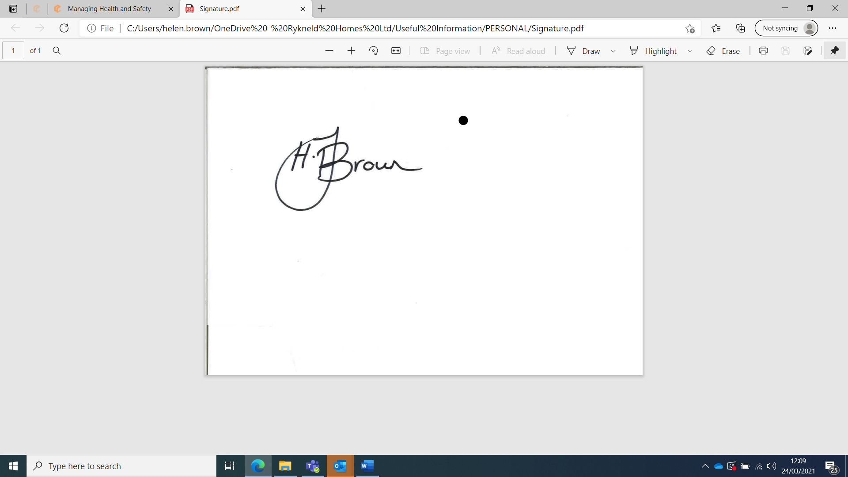

Designation - Head of Regeneration and Development (the officer appointed for this purpose)

Please address any communications to:

Helen Brown
Head of Regeneration and Development
Rykneld Homes Ltd
2013 Mill Lane
Wingerworth
Chesterfield
Derbyshire
S42 6NG
Email: helen.brown@rykneldhomes.org.uk

Schedule – description of building or buildings affected

- No’s 1-50 The Bungalows, Birkinstyle Road, Stonebroom DE55 6LH.

